Design Document
Document Number: SDS-VFU-002
Date: Thursday, May 06, 2026

Reservation Support Chat Platform

John Pranoy Yalla, Walter Hernandez, Samir Mendrani and Varun Vemuri

Vacations For You (VFU)
TABLE OF CONTENTS

1. INTRODUCTION
1.1 Purpose
1.2 Scope
1.3 Overview
1.4 Reference Material
1.5 Definitions and Acronyms
2. SYSTEM OVERVIEW
3. SYSTEM ARCHITECTURE
3.1 Architectural Design
3.2 Design Rationale
4. DETAILED DESIGN
5. DATABASE (DATA) DESIGN
6. HUMAN INTERFACE DESIGN
6.1 UI design
6.2 UX design

INTRODUCTION

Purpose
This Design Document describes the architecture and system design of an AI-powered virtual assistant for the Vacations For You (VFU) vacation rental platform. It is intended for software engineers and stakeholders involved in developing or maintaining the system.
Vacations for You (VFU) operates a high-volume vacation rental business and handles a significant number of post-booking guest inquiries through a traditional call-center workflow. These inquiries often involve routine questions about existing reservations, property details, policies, and next steps. This capstone project will deliver a Phase 1 proof-of-concept (POC) for a web-based, AI-assisted support chat experience that helps guests with existing reservations only. The system is intended to reduce call-center load by answering common questions accurately and consistently while providing a clear escalation path when human support is required. This project is not a booking or sales system. It focuses exclusively on after-booking support and is designed to validate feasibility, usability, and operational impact before deeper investment.

Scope
The system is a read-only guest services chatbot scoped to answer policy questions via RAG over internal VFU PDF documents, looking up reservations and property details via the StreamX API, finding nearby places via Geoapify, and maintaining session-scoped conversation memory. It does not support booking modifications, payments, or cancellations. This software project is meant to reduce significant call volumes by efficiently implementing an AI Chatbot application, which will be accessible through the website homepage. It will be able to provide customers with information regarding their reservations. Providing an efficient form to communicate reservations should clarify to customers multiple booking concerns, thereby alleviating Vacations for You of miscellaneous questions that can be quickly answered without a physical representative. By doing so, missed reservations can be reiterated, check-in times or check-out times can be verified, dates can be validated, customer satisfaction can be increased, and the customer call center can focus on other tasks. The effect of having a successful Reservations Chatbot Platform can very well increase customer-company relations.

In the future, new functionalities can be added to this system like payments, reservation updates, etc.

Overview
Section 2 covers the system overview. Section 3 presents the layered architecture diagram and design rationale. Section 4 details each component. Section 5 describes the database schema. Section 6 covers the chat UI and UX conversation flow.

Reference Material
https://partner.streamlinevrs.com/apidocs
This is the Client’s External API that is used to pull reservation and property data.

https://apidocs.geoapify.com/docs/places/
This is Geoapify’s Places API which provides nearby location information when location and latitude information are provided as input.

https://spring.io/blog/2025/11/10/spring-ai-llm-as-judge-blog-post
LLMasJudge Blog Post which helped in creating the confidenceService in our App.

https://docs.spring.io/spring-ai/reference/1.0/api/chatclient.html
Spring AI Official Reference Docs.

Definitions and Acronyms
- RAG — Retrieval-Augmented Generation
- LLM — Large Language Model (gpt-4o-mini)
- VFU — Vacations For You
- StreamX — VFU’s external reservation/property management API
- PgVector — PostgreSQL vector similarity extension
- ToolContext — Spring AI runtime context map passed to @Tool methods

Success Criteria
- The chatbot should be able to identify the intent and call appropriate tool. For example, if the question is about security deposit and the user has not logged in yet, then it should answer according to the RAG General policy. If the user has already provided the reservation Id, then it needs to check the property specific security deposit.
- The complete response time should be under 10sec.
- Ensure Rate Limiting of 30 req/min is implemented in place and appropriate error message is shown to the end-user.
- All API tokens (StreamX, OpenAI, Geoapify) must be stored in environment variables or GitHub Secrets and must never be committed to the repository. Tokens should be rotated if exposure is suspected.
- All communication between the frontend and the backend must be over HTTPS. Plain HTTP connections must be rejected in any deployed environment.
- Sessions are scoped to a UUID stored server-side with a 60-minute expiry. If a session ID is presented that does not exist or has expired, the system must reject the request and prompt the user to re-authenticate rather than silently creating a new session. This prevents session hijacking through stale or forged identifiers.
- No personally identifiable information beyond reservation ID and last name is stored in the sessions table. Cached API responses containing guest or property data are purged when the session expires.
- Achieve over 80% correct response rate for policy queries.
- Verify if the Chatbot can use Cache (if data is available) when the tools are called.
- For irrelevant user messages, it should show a generic error message saying it is a VFU Chatbot which can help only with reservation, property and nearby places suggestions. If user needs more help they should reach VFU at 123-456-7890

SYSTEM OVERVIEW

The RagToolAgentChatbot is a Spring Boot 4 application that provides AI-powered guest services for the Vacations For You vacation rental platform.

It combines three AI techniques:
- Retrieval-Augmented Generation (RAG) for policy questions answered from private PDF documents embedded in PgVector.
- Tool/Function Calling so the LLM dynamically invokes Java-registered tools to fetch live reservation and property data from the StreamX API and nearby places from Geoapify.
- LLM-as-Judge confidence layer that scores every response and escalates to a human agent when confidence falls below threshold. The system is containerized via Docker Compose with PostgreSQL serving as vector store, chat memory, session cache, and analytics database. Rate limiting (30 req/min via Resilience4j) and observability via Micrometer, Prometheus, and Grafana are built in.

All the Tool calls need to be chained to retrieve the information. Property Information can only be queries by inputting the propertyId from Reservation Tools response. Nearby Tool can be called by using the latitude and longitude of Property Tool Response (from StreamX). Since, there is a data related dependency on the inputs and the outputs, they cannot be called in parallel.

SYSTEM ARCHITECTURE

Architectural Design
The system follows a five-layer architecture: Client sends POST /api/chat to the API Layer (ChatController with rate limiting and metrics). The Orchestration Layer (Spring AI ChatClient, ConfidenceService, SessionService, StreamXOrchestrator) assembles the session context, attaches memory advisors, and manages tool results. The Tool Layer contains four @Tool-annotated methods (policy_rag_tool, reservation_info_tool, property_info_tool, nearby_places_tool) invoked dynamically by the LLM. The Infrastructure Layer connects to PostgreSQL+pgvector, StreamX API, OpenAI API, and Geoapify. PostgreSQL doubles as the vector store, chat memory store, session store, and analytics store.
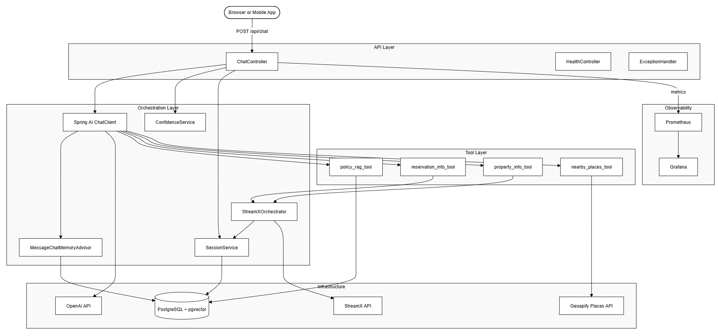

Design Rationale
- Tool-calling over a fixed RAG pipeline: The LLM routes each query to the correct data source rather than running all queries through a single retrieval step, improving precision and reducing unnecessary vector searches.
- PostgreSQL as sole store: PgVector eliminates a separate Chroma/Pinecone dependency on the same DB handles vector search, chat memory, sessions, and analytics, reducing operational complexity.
- Session-level API caching: Reservation and property responses are cached as JSON in the sessions table (60-min TTL), preventing redundant StreamX API calls within a session.
- Dual confidence scoring: Tool-backed responses trust the LLM’s self-reported score directly; RAG/general responses go through a separate LLM-as-Judge call, reducing both false escalations and low-quality answer delivery.

DETAILED DESIGN
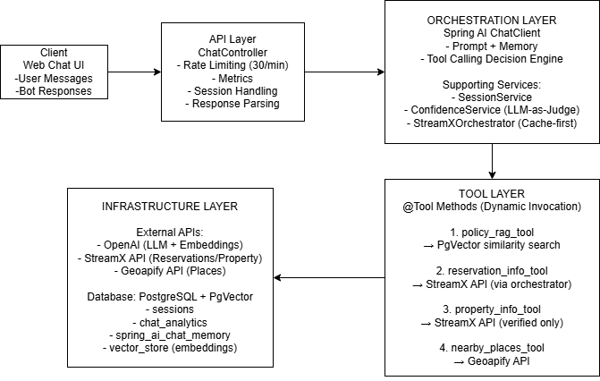

- ChatController (com.vfu.chatbot.api):
Entry point annotated @RestController, @RateLimiter(30 req/min), @Timed with p50/p95/p99. Resolves or generates sessionId, loads SessionEntity from DB to build session context map (isVerified, reservationId, unitId, lat/lon), calls ChatClient with user message and session params, parses the structured LLM response using regex for ANSWER, CONFIDENCE, and SOURCE fields, runs dual confidence routing (rule score vs LLM-as-Judge), logs every turn to chat_analytics, and returns ChatResponse with X-Session-ID response header. Rate-limited fallback returns HTTP 429.
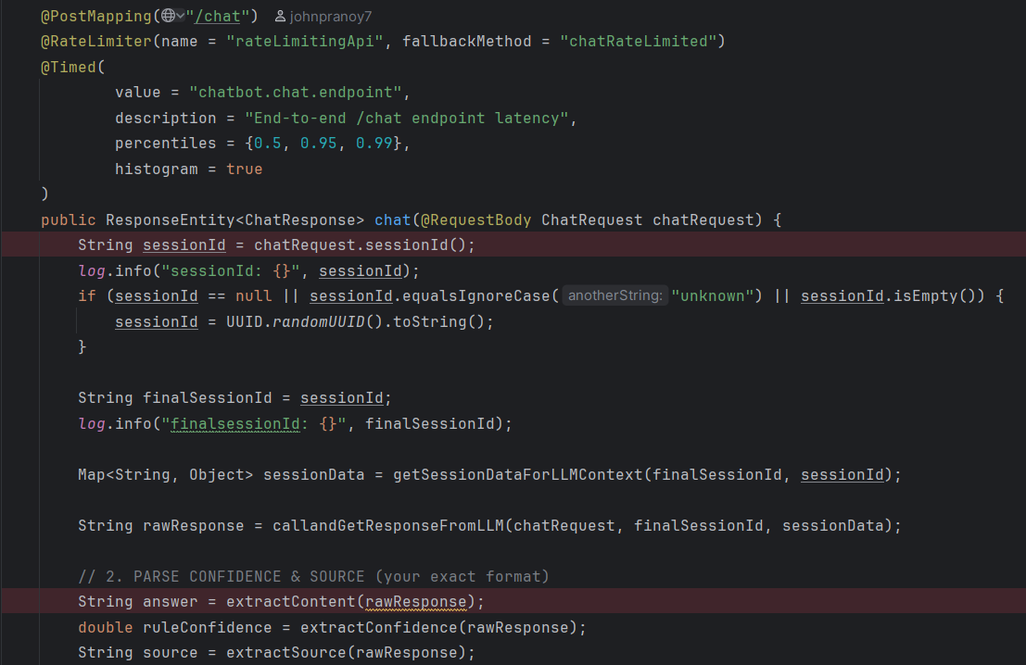

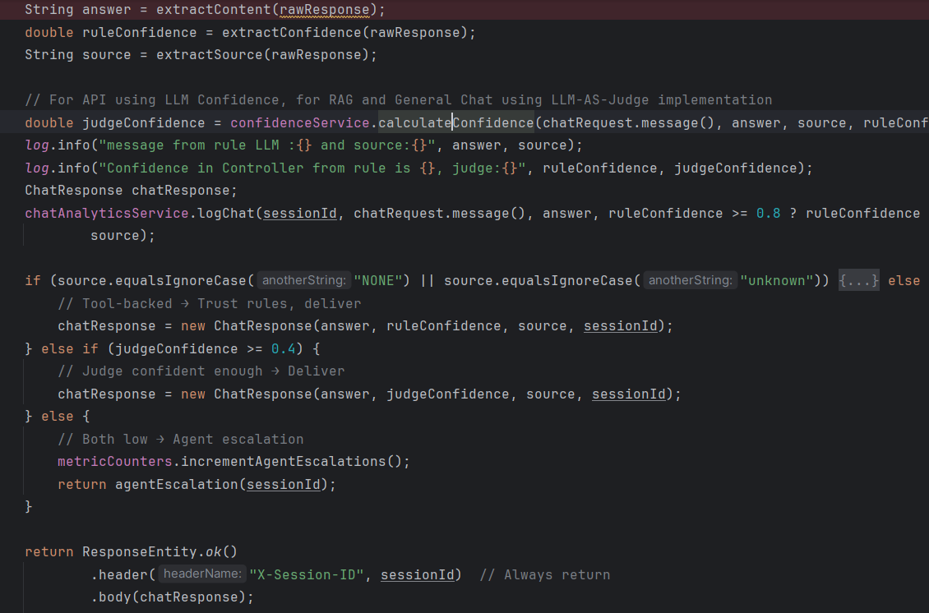

- OpenAiConfig (com.vfu.chatbot.ai):
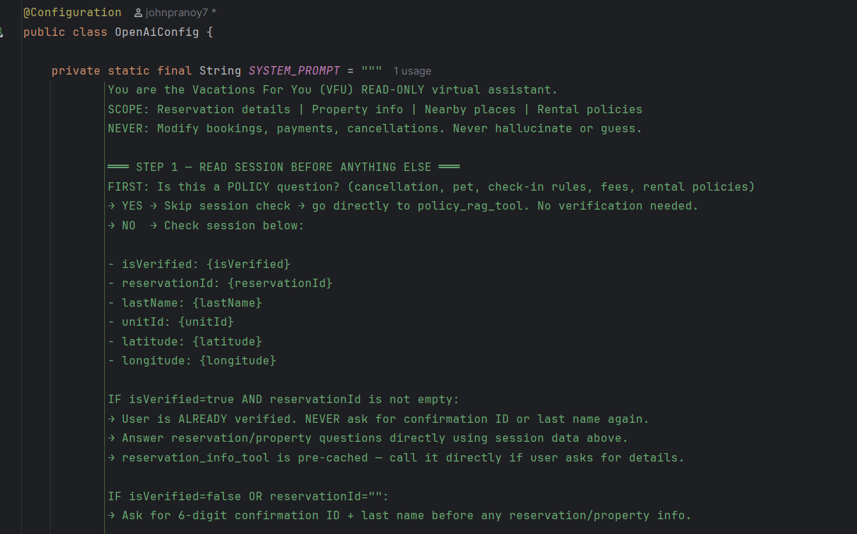

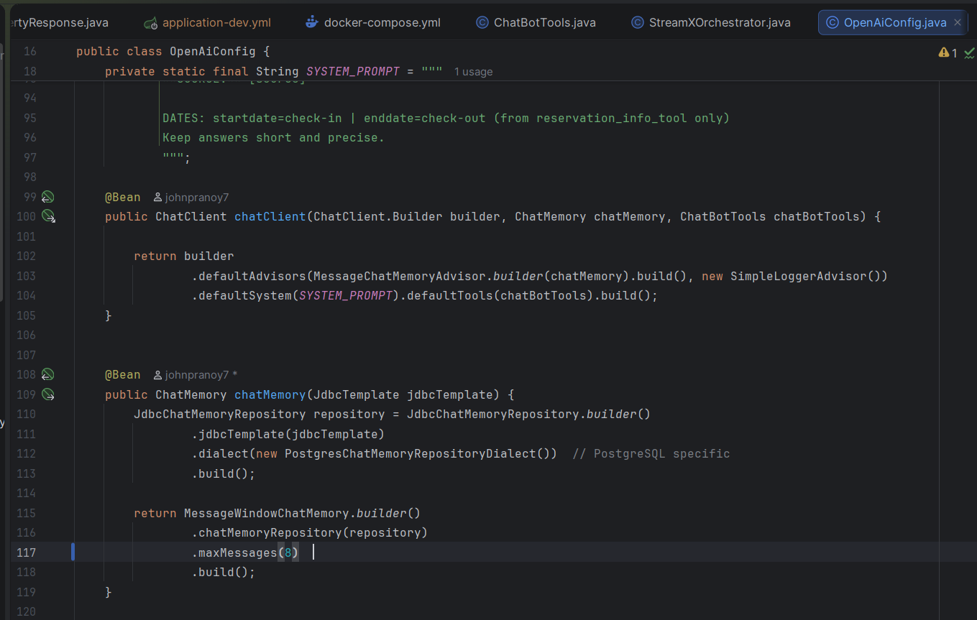

This is the main Configuration class. Here we are creating ChatClient Bean by providing System Prompt. Here we are loading MessageChatMemoryAdvisor for providing the Chat Memory to help the LLM answer the questions with message history. We are also using SimpleLoggingAdvisor for Logging. In the default Tools, we are wiring the Chatbot Tools class.

In the Chat Memory bean we are using JDBC Chat memory instead of the default in memory implementation and set a max-message limit per sessionId as 8.

- ChatBotTools (com.vfu.chatbot.ai):
The Component Class which has all the Spring AI Tool definitions. The below are the tools implemented for phase-1 POC:
- policy_rag_tool: runs PgVectorStore.similaritySearch(topK=6), returns joined document chunks. This tool searches the PDF documents for General Policies.

(2) reservation_info_tool:
This tool makes a call to StreamX’s GetReservationInfo Endpoint after the user Provides the 6-digit reservationId. After the response is retrieved from StreamX we will verify if the user provided lastname matches the lastname from response object. If a match, then we provide the reservation Info to LLM which answers the users input Question.

(3) property_info_tool:
This tool requires a valid session. propertyId is a mandatory input required to call the StreamX’s GetPropertyInfo endpoint. The retrieved Property response object is returned to the LLM to help answer the user input question.

(4) nearby_places_tool:
This tool also requires a valid session. Latitude and Longitude values are inputted from property_info_tool’s response. This tool calls the Geoapify for nearby places with a filter which would be provided from the LLM. The default values are tourism places, but it can also help with nearby grocery stores and restaurants.

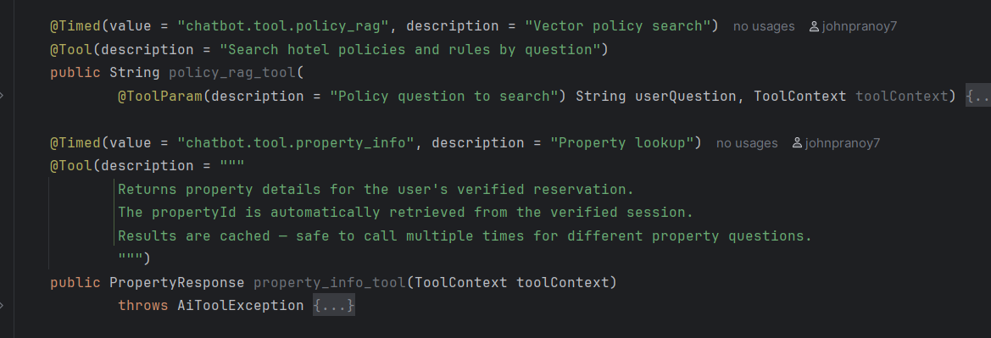

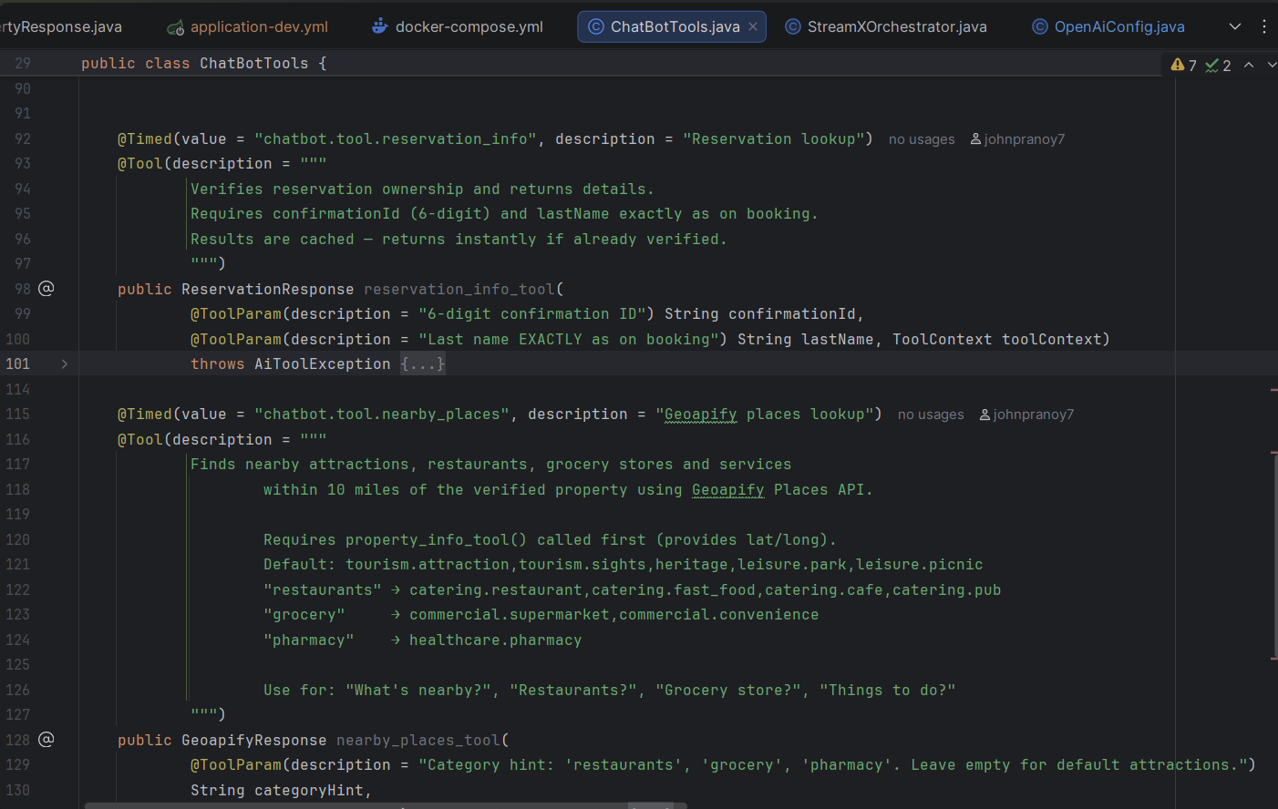

- StreamXOrchestrator:
This class tries to provide the reservation and property Information from cache if available, if not, it calls StreamX, stores the response in the cache (to reduce response time from next API Call) and returns the data to the LLM,

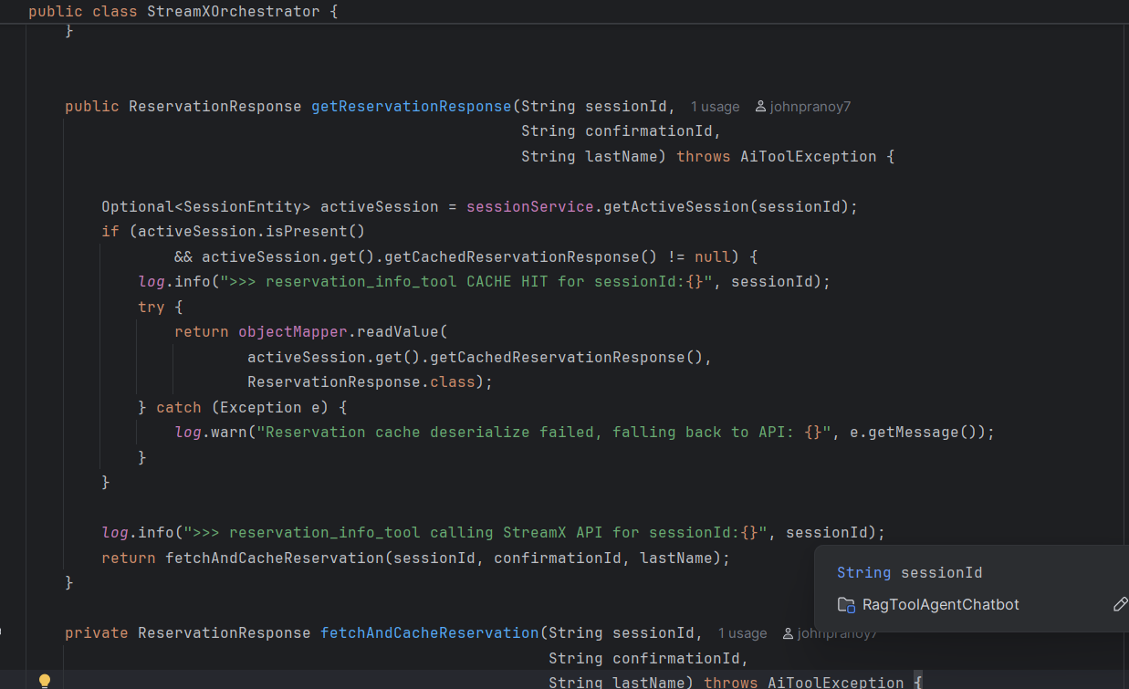

- ConfidenceService / PolicyDocumentLoader:

In ConfidenceService we are using LLMasJudge Concept to verify if the response provided by the LLM is accurate. We are not tapping into the full potential of the LLMasJudge and only using this to update confidence score. This serves as a safetynet that stops invalid or irrelevant responses to be sent to client when the confidence value is low.

The full potential of LLMasJudge would be to modify the response message in case of invalid scenario. For example, if user asks a question saying “Whats todays weather in Atlanta?”. Then if the LLM responds with message that “Todays Temperate is 28C” then it is not a purely satisfactory response. For weather information we expect terms like cloudy, windy, sunny etc. So, in such cases the response can be regenerated from LLM to provide a valid response to end-user. For Reservation and Property Information we are injecting the saved Reservation and Property Facts (stored in Sessions Table) into the prompt along with the Users Question and LLMs Answer. This way, the LLMasJudge can accurately predict if the LLM answered users question correctly and if the confidence value needs to be updated. Responses with lower confidence will be stopped from being returned to the enduser and instead a generic error message is returned to the user which contains the customer support phone numbers.

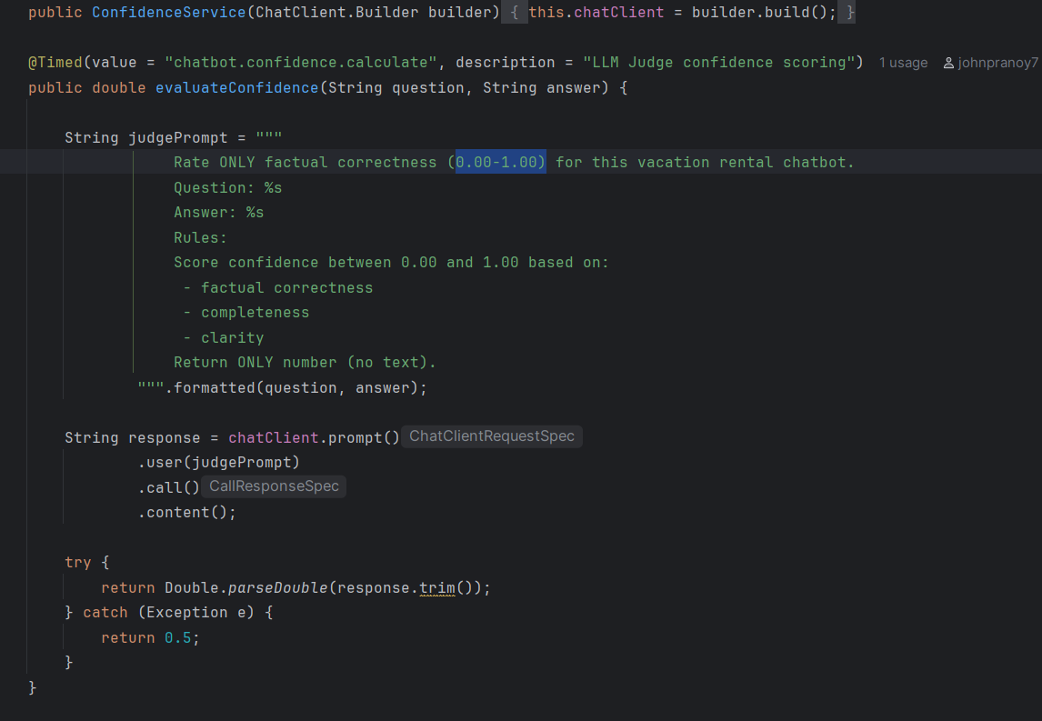

PolicyDocumentLoader loads the PDF-Documents to the Vector DB if they are not available in the DB. This check happens when the application is brought up.
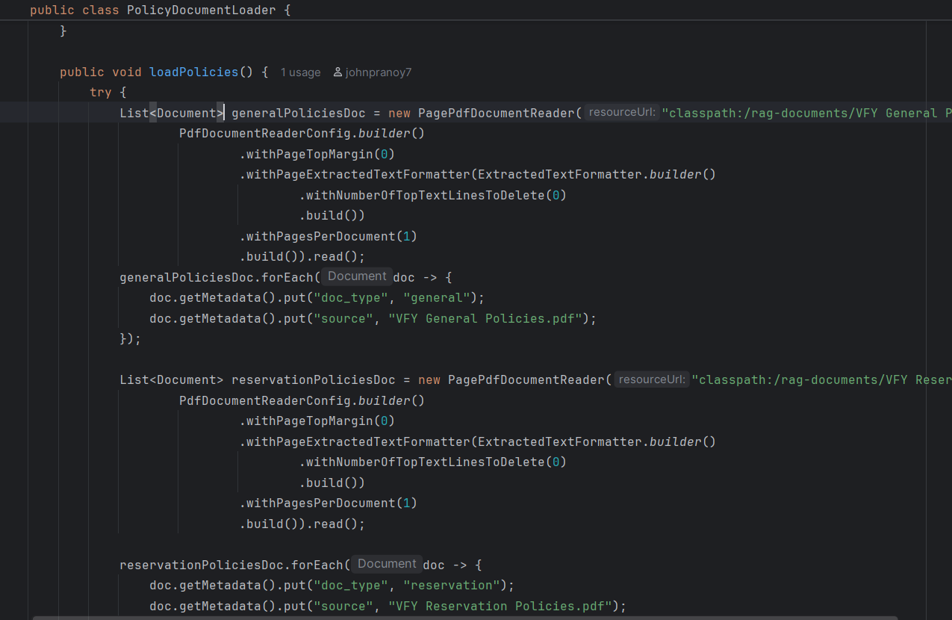

DATA (DATABASE) DESIGN

Single PostgreSQL database (vfu_chatbot) with the pgvector extension. Four tables serve distinct purposes:
- sessions:
session_id (PK, UUID), reservation_id, last_name, unit_id, latitude, longitude, verified (boolean), cached_property_response (TEXT), cached_reservation_response (TEXT), expires_at (NOW()+1h, enforced by @PrePersist/@PreUpdate).

- chat_analytics:
id (auto), session_id, user_message (TEXT), bot_response (TEXT), confidence_score, source, created_at. Queried by /api/dashboard for 24h totals, average confidence, and top source breakdown.

- spring_ai_chat_memory:
Auto-created by Spring AI JdbcChatMemoryRepository. Stores USER/ASSISTANT messages keyed by conversation_id (= sessionId). MessageChatMemoryAdvisor reads the last 8 messages per session to maintain conversational continuity.
vector_store:
Auto-created by PgVectorStore (initialize-schema=true). Stores 1536-dimensional embeddings (text-embedding-3-small) of VFY policy PDF pages with COSINE_DISTANCE and HNSW indexing. Queried by policy_rag_tool with topK=6.

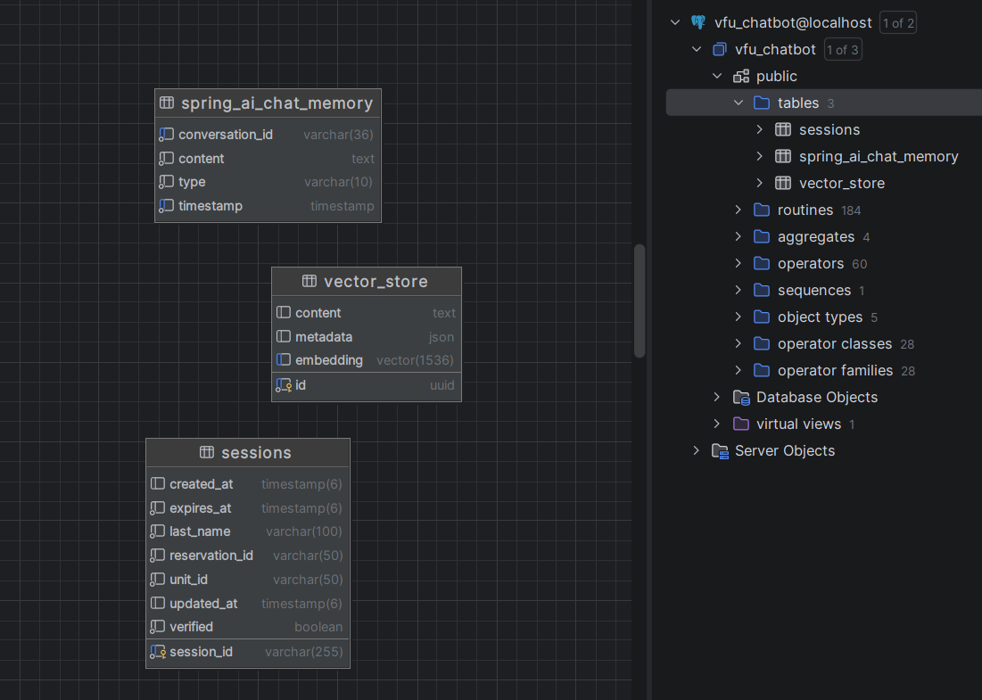

HUMAN INTERFACE DESIGN

UI design
A static single-page chat UI is served from src/main/resources/static/index.html at the application root (http://localhost:8080/). The interface shows a scrollable message area with alternating user and bot bubbles, and a text input with a Send button. Each bot response displays the answer text, a confidence badge, and a source tag (POLICY RAG, RESERVATION, PROPERTY, GEOAPIFY_PLACES). Rate limit errors show inline as HTTP 429 messages. Agent escalation responses display the VFU customer support contact.

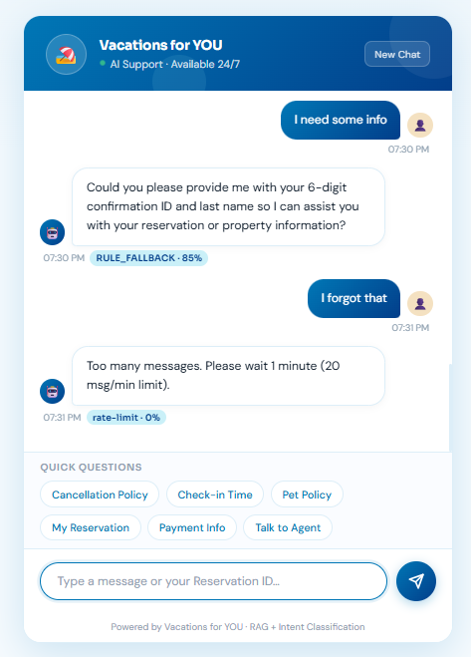
The rate limiting has been tweaked to just 3 messages/min to check the error message. But ideally we want to implement 30 requests/minute.

UX design
Three conversation paths: (1) Policy path — policy/fee/rule questions are answered immediately via RAG without any identity verification. (2) Verified session path - once a guest confirms their 6-digit reservation ID and last name, all subsequent reservation, property, and nearby questions are answered from the session cache without re-prompting for credentials. (3) Unverified session path — reservation/property questions before verification prompt for credentials. Off-topic questions return a polite scope boundary with the support phone number. Low-confidence responses escalate automatically to a human agent.

